Multi-Agent E-Commerce Shopping Assistant: AI-Powered Personalized Product Recommendation System -Multi Agents - Gemini 2.5 flash

Project Description:
The Multi-Agent E-Commerce Shopping Assistant harnesses Generative AI and multi-agent collaboration to help customers make informed purchasing decisions. The platform includes a Requirement Analysis Agent, which extracts category, budget, specifications and preferences from a natural-language request. A Product Search Agent retrieves matching products from the catalog. A Review Analysis Agent summarizes strengths, weaknesses and common concerns from customer feedback. Price and Specification Comparison Agents compare the shortlisted products. A Recommendation Agent ranks them and explains why each one fits, and an Alternative Recommendation Module suggests other options when no product fully satisfies the request.
Using a Retrieval-Augmented Generation (RAG) pipeline, the assistant grounds every response in real product catalog data rather than the language model's general knowledge. The system is orchestrated with LangGraph, powered by Groq's API with the LLaMA 3.3-70B Versatile model, and delivered through an interactive Streamlit dashboard. With secure API key management via .env and responsible input handling, the assistant gives customers a faster, more transparent and more personalized shopping experience.

Scenarios
Scenario 1: A customer enters: "Find a laptop under ₹70,000 with 16GB RAM, good battery life, high customer ratings, and suitable for programming." The Requirement Analysis Agent extracts the category, budget, RAM and use case. The Product Search Agent shortlists matching laptops, the Review Analysis Agent summarizes battery and build-quality feedback, and the Recommendation Agent returns a ranked list with a clear explanation for each pick.
Scenario 2: A customer wants a smartphone under ₹25,000 with a strong camera, but no product meets every requirement. The system identifies which constraints are unmet, then the Alternative Recommendation Module suggests slightly higher-priced or lower-spec options, showing the trade-offs.
Scenario 3: A customer is undecided between three shortlisted headphones. The Price Comparison and Specification Comparison Agents produce a side-by-side table, the Review Analysis Agent surfaces common complaints for each, and the Explanation Module states which product suits the customer's priorities best and why.

Technical Architecture:

Description:
The Multi-Agent E-Commerce Shopping Assistant uses a modular layered architecture. The frontend is an interactive Streamlit interface where customers enter natural-language requests. The backend is a LangGraph-based orchestration layer that passes a shared state through specialized agents in sequence. Each agent either calls the Groq LLM, queries the product catalog, or retrieves context from the RAG knowledge base. The catalog is stored in a relational database (SQLite), and product descriptions and reviews are embedded and stored in a vector store (ChromaDB) for retrieval. The app runs locally through Streamlit and can be exposed publicly through Ngrok.
Architecture flow:
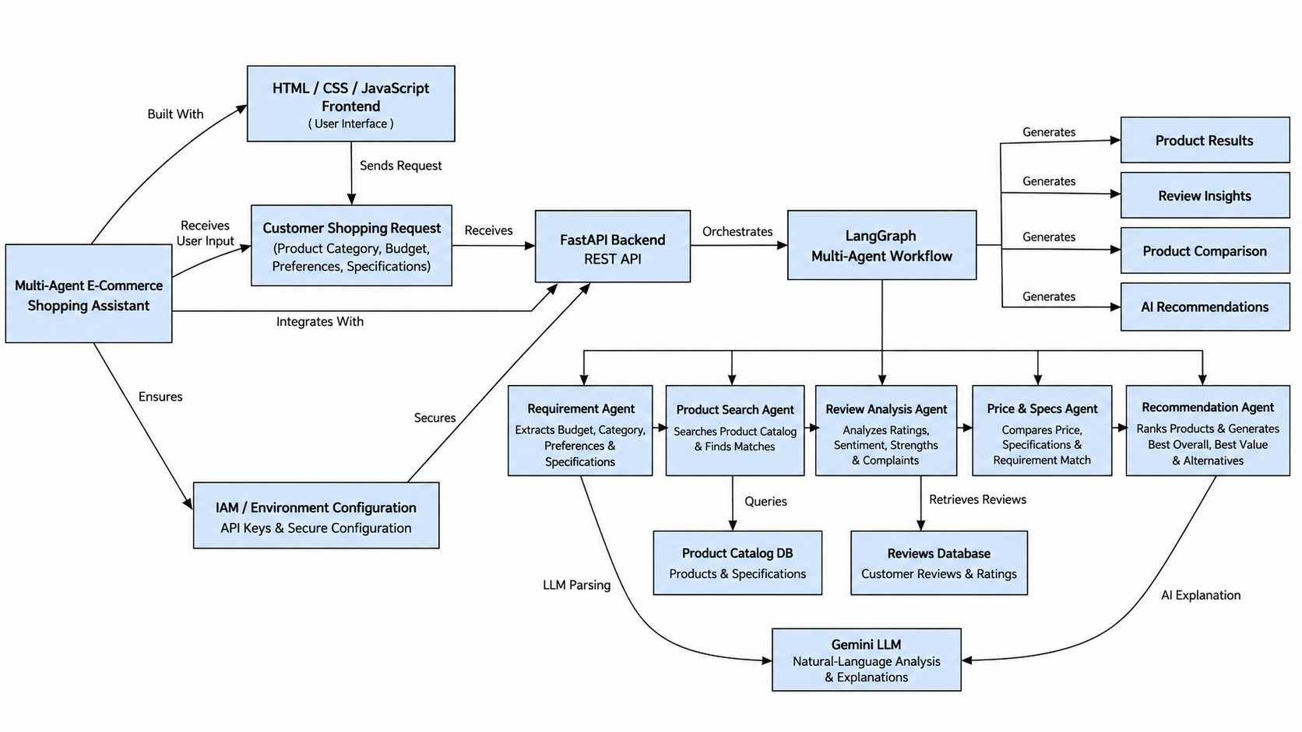

Pre-requisites:
- Streamlit Framework Knowledge: Streamlit Documentation (https://docs.streamlit.io/)
- LangGraph / Multi-Agent Concepts: LangGraph Documentation (https://langchain-ai.github.io/langgraph/)
- Groq API Familiarity: Groq API Documentation (https://console.groq.com/docs/openai)
- RAG and Vector Databases: ChromaDB Documentation (https://docs.trychroma.com/)
- SQL / SQLite Basics: SQLite Documentation (https://www.sqlite.org/docs.html)
- Python Programming Proficiency: Python Documentation (https://docs.python.org/3/)
- Version Control with Git: Git Documentation (https://git-scm.com/docs/git)
- Development Environment Setup: VS Code Documentation (https://code.visualstudio.com/docs)
- Ngrok for Public Deployment: Ngrok Documentation (https://ngrok.com/docs)

Project Workflow:

Milestone 1: Model Selection and Architecture
- Activity 1.1: Generate a Groq API key and configure it securely in the project environment.
- Activity 1.2: Research and select the appropriate LLM and multi-agent framework for the shopping assistant.
- Activity 1.3: Define the architecture of the application, detailing interactions between the frontend, agents, RAG module and product catalog.
- Activity 1.4: Set up the development environment, installing the necessary libraries and dependencies.

Milestone 2: Core Functionalities Development
- Activity 2.1: Build the product catalog database and the RAG knowledge base.
- Activity 2.2: Develop the specialized agents: Requirement Analysis, Product Search, Review Analysis, Price Comparison, Specification Comparison and Recommendation.

Milestone 3: App.py Development
- Activity 3.1: Write the orchestration logic and the main application in app.py, connecting the agent workflow to the user interface.

Milestone 4: Frontend Development
- Activity 4.1: Design and develop the Streamlit shopping dashboard.
- Activity 4.2: Render recommendations, comparisons, review insights and alternatives dynamically.

Milestone 5: Deployment
- Activity 5.1: Prepare the application for local deployment.
- Activity 5.2: Test the application locally.
- Activity 5.3: Deploy the application publicly using Ngrok.

Milestone 6: Conclusion

Milestone 1: Model Selection and Architecture
In this milestone, we select the LLM and multi-agent framework for the shopping assistant. This involves researching the capabilities of the available models, ensuring the chosen model can extract structured requirements, analyze reviews and generate clear explanations, and defining how all system components communicate.

Activity 1.1: Generate a Gemini API Key
Before the agents can communicate with the LLM, you need a valid Groq API key.
- Step 1: Create a Gemini Account: Visit https://gemini.api.com/keys and sign up using your Google account or email address.
- Step 2: Create a New API Key: Click "Create API Key" and give it a descriptive name (e.g., shopping-assistant-key).
- Step 3: Copy the Key: Set a display name (expiration is optional) and click "Submit". Copy the key immediately and store it safely. You cannot view it again after closing the dialog.
- Step 4: Add the Key to Your Project: Create a .env file in the project root and add:
- Step 5: Verify the Key is Loaded: app.py loads this key at startup using python-dotenv:
python
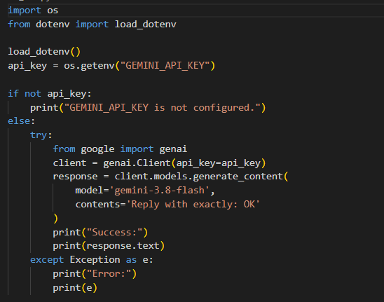
- Important: Never Commit Your API Key. Add .env to your .gitignore file:
.env

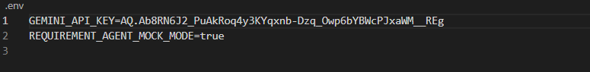

Activity 1.2: Research and Select the Appropriate Model and Framework
Here are the things to research when selecting the best model and framework:
- Understand the Project Requirements: Review the needs of the assistant: extracting structured requirements, summarizing reviews, comparing products and generating explanations.
- Explore Gemini API Model Documentation: Examine the available LLMs, including their context windows, speed and limitations.
- Evaluate Model Performance: Compare models on reasoning quality, structured (JSON) output reliability and response speed.
- Select the Optimal Model: Choose llama-3.3-70b-versatile for its balance of reasoning quality and speed, with a low temperature (0.2 to 0.3) for consistent, factual agent outputs.
- Select the Multi-Agent Framework: Choose LangGraph because it models the workflow as a graph of agents sharing a common state, which makes the sequence easy to trace and debug. (CrewAI is a valid alternative.)
- Select the RAG Components: Use ChromaDB as the vector store with a sentence-transformer embedding model for semantic retrieval.

Activity 1.3: Define the Architecture of the Application
- Draft an Architectural Diagram: Create a visual representation of the frontend (Streamlit), the orchestration layer (LangGraph), the agents, the RAG module and the product catalog database.
- Detail Frontend Functionality: Outline how customers enter a natural-language request, optionally set filters (budget, brand), and view ranked recommendations, comparisons and alternatives.
- Outline Backend Responsibilities: Specify how the orchestration module validates the input, initializes the shared state, and runs the agents in order.
- Describe AI Integration Points: Define how each agent builds its own prompt, calls the Groq API, parses the JSON response and writes its result into the shared state for the next agent.
- Define the Shared State: All agents read from and write to a single state object containing the user query, extracted requirements, shortlisted products, review insights, price analysis, specification comparison, recommendations, alternatives and the final explanation.

Activity 1.4: Set Up the Development Environment
- Install Python and Pip: Ensure Python 3.10+ is installed along with pip.
- Create a Virtual Environment:
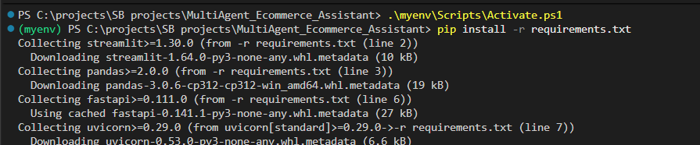
- Install Gemini API :
- Install LangGraph:
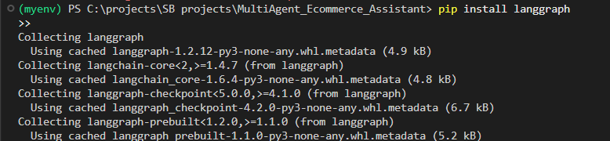
- Install RAG Dependencies:
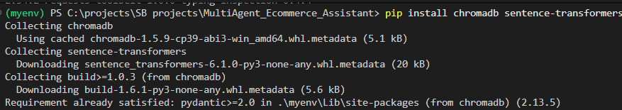
- Install python-dotenv:
- Configure the API Key: Create a .env file in the project root and add your Gemini API key.
- Set Up Application Structure:
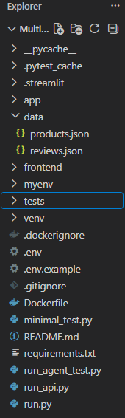

Milestone 2: Core Functionalities Development

Activity 2.1: Build the Product Catalog and RAG Knowledge Base
Product Catalog Database:
- Create a SQLite database (data/catalog.db) with three tables, products, specifications and reviews, matching the ER diagram above.
- Populate it with a sample product dataset covering multiple categories (laptops, smartphones, headphones, etc.).
RAG Knowledge Base:
- Convert each product's description, specifications and review text into text chunks.
- Generate embeddings for each chunk and store them in a ChromaDB collection with the product_id as metadata.
- Implement a retriever that takes a query and returns the top-k most relevant chunks.
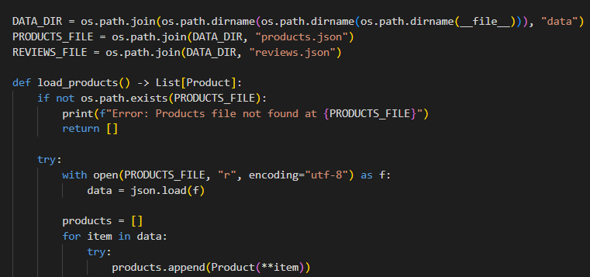
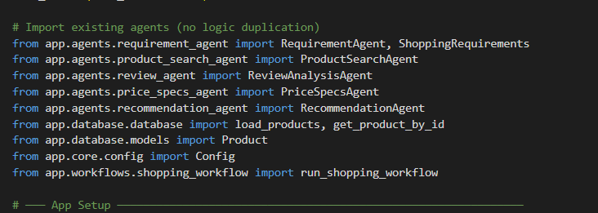
Activity 2.2: Develop the Specialized Agents
Each agent is a Python function that receives the shared state, performs one task and returns its updates to the state.
- Requirement Analysis Agent: Sends the customer's request to the LLM with a prompt that extracts category, budget, specifications, brand preferences and desired features as strict JSON.
- Product Search Agent: Queries the catalog database with the extracted filters (category, budget) and uses the RAG Module to retrieve semantically relevant products. Returns a shortlist.
- Review Analysis Agent: Retrieves each shortlisted product's reviews and asks the LLM to summarize positive feedback, negative feedback, strengths and common issues.
- Price Comparison Agent: Compares prices, flags products within budget and identifies the best value.
- Specification Comparison Agent: Compares key specifications (e.g., RAM, battery, processor) against the customer's requirements.
- Recommendation Agent: Combines all the analysis, ranks the products against the customer's requirements and generates a personalized recommendation.
- Alternative Recommendation Module: When no product satisfies every requirement, suggests alternatives and states which requirement was relaxed.
- Explanation Module: Produces clear reasons for each ranking, including strengths, limitations and comparison against other options.
Example: Requirement Analysis Agent
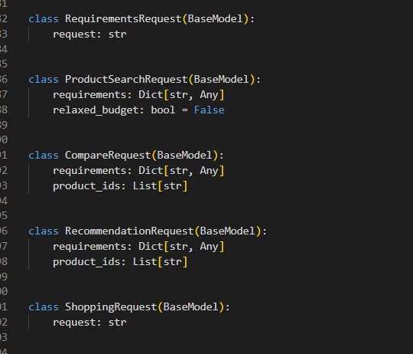

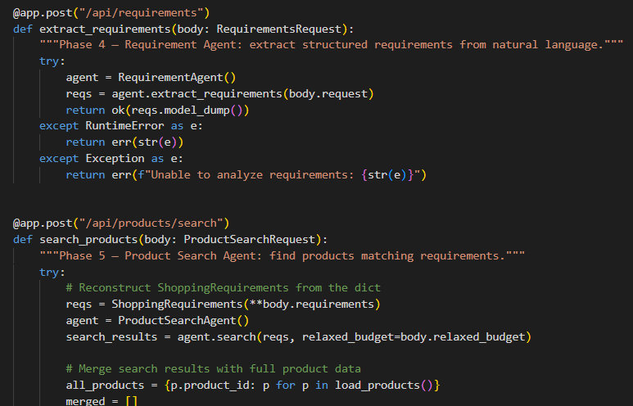
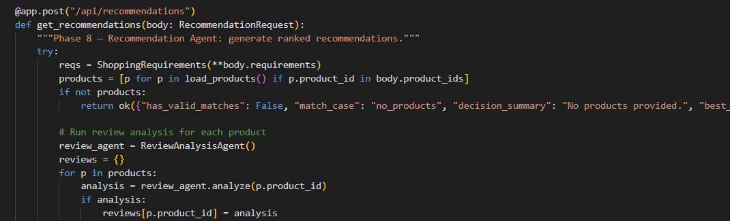

Milestone 3: App.py Development
Milestone 3 focuses on the core logic that connects the agents into one workflow and serves it through app.py. In this milestone, you define the shared state, register every agent as a graph node, connect them in order and expose the compiled workflow to the Streamlit interface.

Activity 3.1: Writing the Main Application Logic
Define the Shared State:
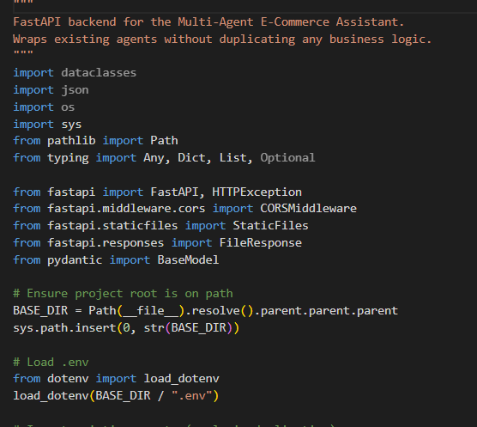
Build the Multi-Agent Orchestration Workflow (orchestrator.py):
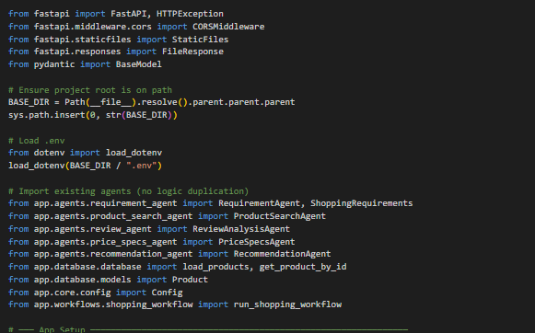
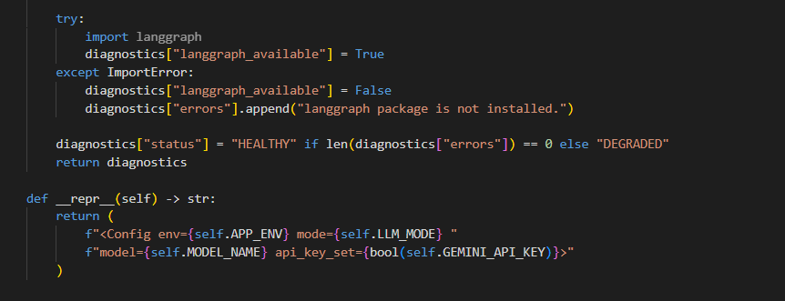
Apply Input Validation in app.py:
- Reject empty requests.
- Limit the request length (e.g., 1000 characters).
- Handle the case where no products are found in the catalog by showing a friendly message instead of an error.
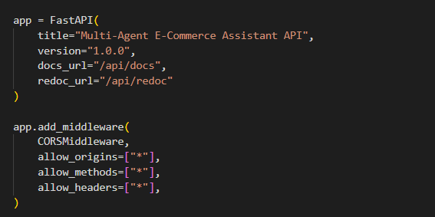
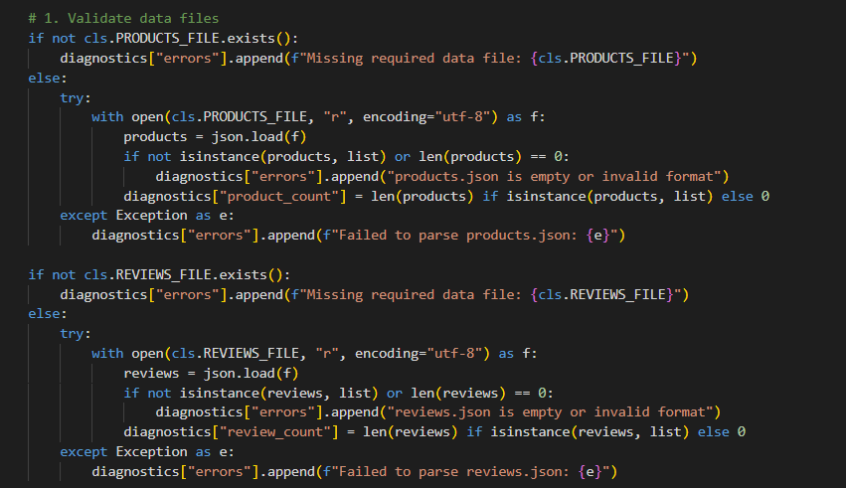
Robust JSON Parsing (utils.py):
- extract_json(): first attempts a direct json.loads(), then strips markdown code fences, and finally uses a regex to locate a raw JSON object, so every agent's output is parsed reliably.
Error Handling:
- Wrap the workflow call in try/except and show a readable error in the UI if any agent fails.
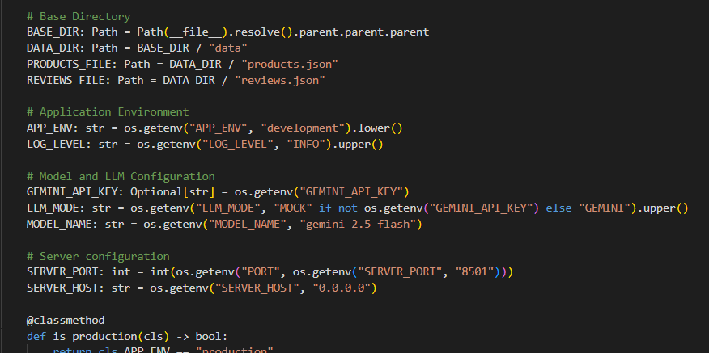

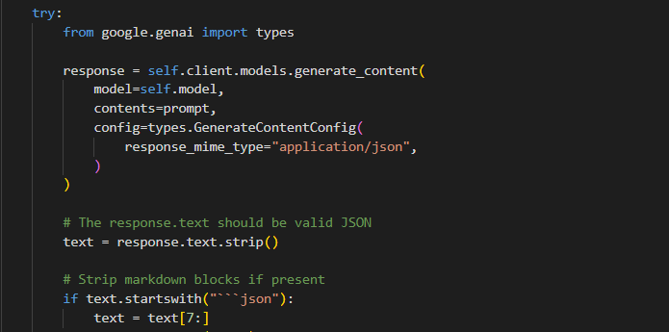

Milestone 4: Frontend Development
Milestone 4 focuses on building an interactive, user-friendly shopping dashboard in Streamlit. This involves collecting the customer's request and rendering ranked recommendations, comparisons, review insights, prices, specifications and alternatives.

Activity 4.1: Designing and Developing the User Interface
Set Up the Base Page Structure:
- Configure the page with a title, icon and wide layout using st.set_page_config().
- Add a header with the application name and a short tagline.
- Add an input section and a results section on a single page.
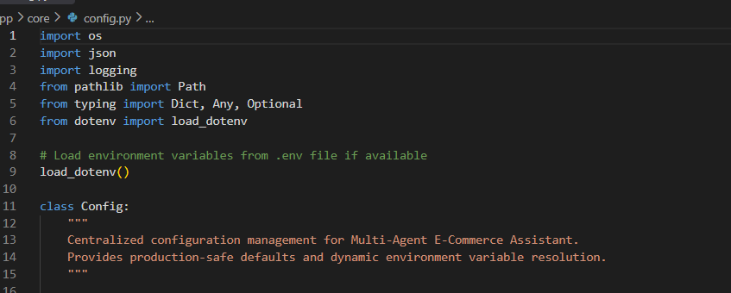
Create the Input Section:
- A text area for the natural-language shopping request.
- Optional sidebar filters for budget range and preferred brands.
- A "Find Best Products" button.
Create Separate UI Components for Each Output Type:
- Recommendation Cards: One card per ranked product showing name, price, rating and the explanation for the ranking.
- Comparison Table: A side-by-side table of price and key specifications for the shortlisted products.
- Review Insights Panel: Positive feedback, negative feedback and common issues per product.
- Alternatives Section: Suggested alternative products with the trade-offs.
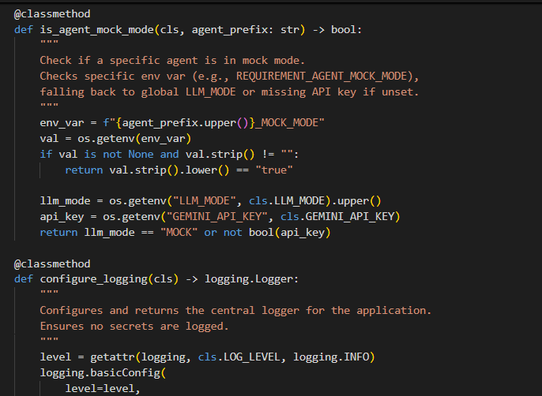

Activity 4.2: Creating Dynamic Content Rendering
Handle the Request:
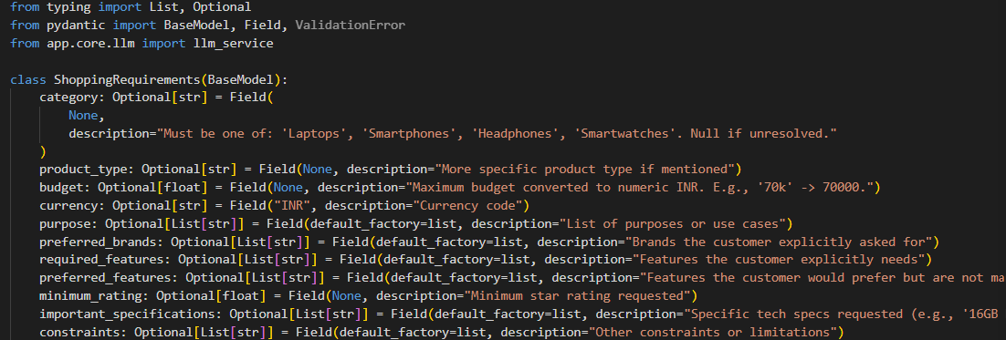
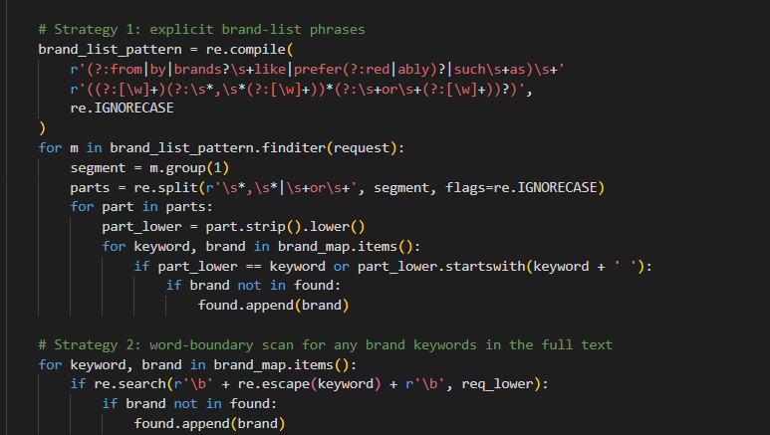
Render Results Dynamically:
- Implement render_results(result), which uses st.columns, st.dataframe and st.expander to display the recommendations, comparison table, review insights and alternatives.
- Show the spinner while the agents run so the customer knows the request is being processed.
- Use st.session_state to keep the results visible when the customer interacts with other widgets.
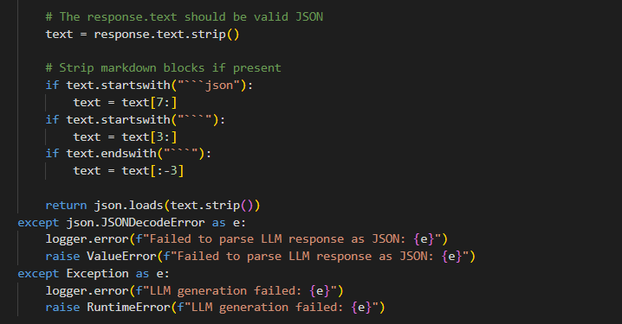

Milestone 5: Deployment
In Milestone 5, the focus is on deploying the application locally to verify correct operation, and then publicly via Ngrok to share it over a secure URL.

Activity 5.1: Preparing the Application for Local Deployment
Set Up a Virtual Environment:
- Open a new terminal, then open "Command Prompt".
- Create and activate a virtual environment, then install all required dependencies.
Configure Environment Variables:
- Create a .env file in the project root and add your Groq API key:
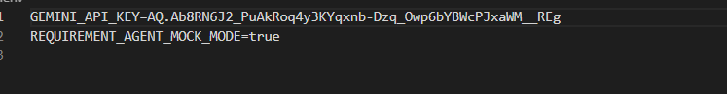

Activity 5.2: Local Testing and Verification
Start the Server:
- Once running, open a browser and navigate to http://localhost:8501.
- Test different requests (budget-based, specification-based, brand-based) and confirm that requirements are extracted correctly, matching products are found, reviews are summarized, and the ranking and explanation are generated.
- Test an impossible request (e.g., a very low budget) to verify the alternatives section works.

Activity 5.3: Public Deployment via Ngrok
Ngrok creates a secure tunnel from a public URL to your local Streamlit server, making the app accessible from anywhere without a cloud hosting provider.
Install Ngrok and pyngrok:
- Install the pyngrok Python wrapper:
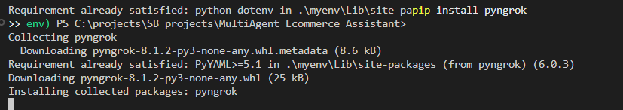
- Download and install the Ngrok client from https://ngrok.com/download.
- Click on "Microsoft Store Installer".
Configure Your Ngrok Authtoken:
- Sign up at ngrok.com and copy your authtoken from the dashboard.
- The run_public.py script sets the authtoken using
- Replace the token value in run_public.py with your own authtoken before running.
Run the Public Deployment Script:
- Launch run_public.py to start both the Streamlit server and the Ngrok tunnel:
- The script opens an HTTP tunnel on port 8501 and prints the live public URL:
- Share this URL with anyone who can then access the assistant directly from their browser without any installation.
Important Notes:
- Run Streamlit in headless mode (--server.headless true) inside run_public.py so it does not try to open a local browser window.
- The public URL changes each time you restart run_public.py on the free Ngrok plan. For a persistent URL, upgrade to a paid plan and configure a reserved domain.
- Ngrok free tier sessions expire after a few hours. Restart run_public.py to get a new URL when this happens.

Exploring the Website's Web Pages:
Dashboard Page

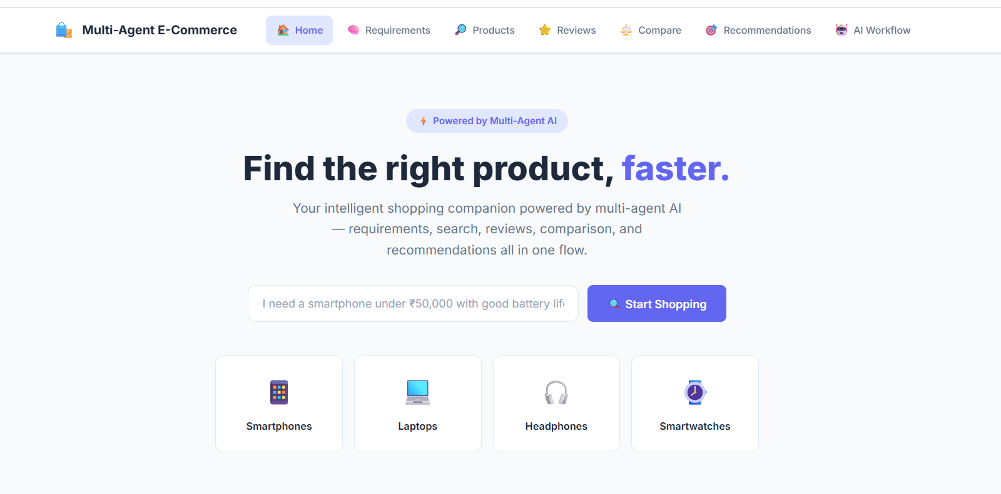
This image shows the home page of a Multi-Agent E-Commerce shopping platform. It features an AI-powered shopping assistant that helps users find products faster through requirements, product search, reviews, comparison, and recommendations. The page also provides quick categories for Smartphones, Laptops, Headphones, and Smartwatches.
Requirements Page :

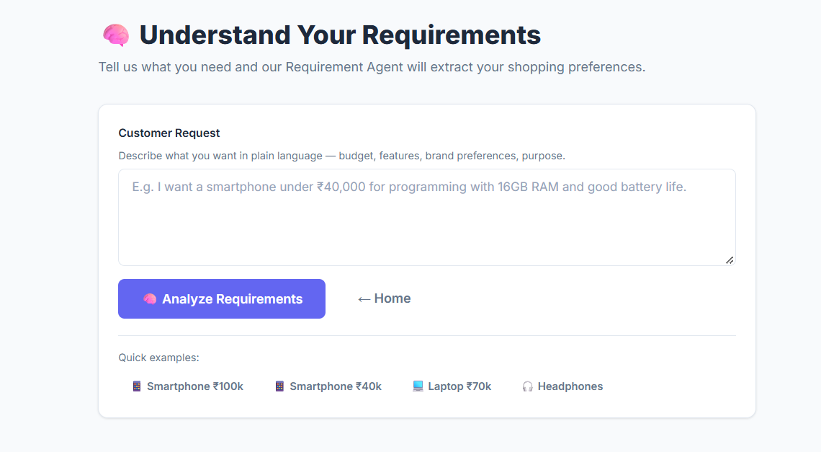
This Requirements page allows users to describe their shopping needs in plain language, including budget, features, brand preferences, and purpose. The Requirement Agent analyzes the request and extracts the user’s preferences, with quick examples for different product categories.
Products Page
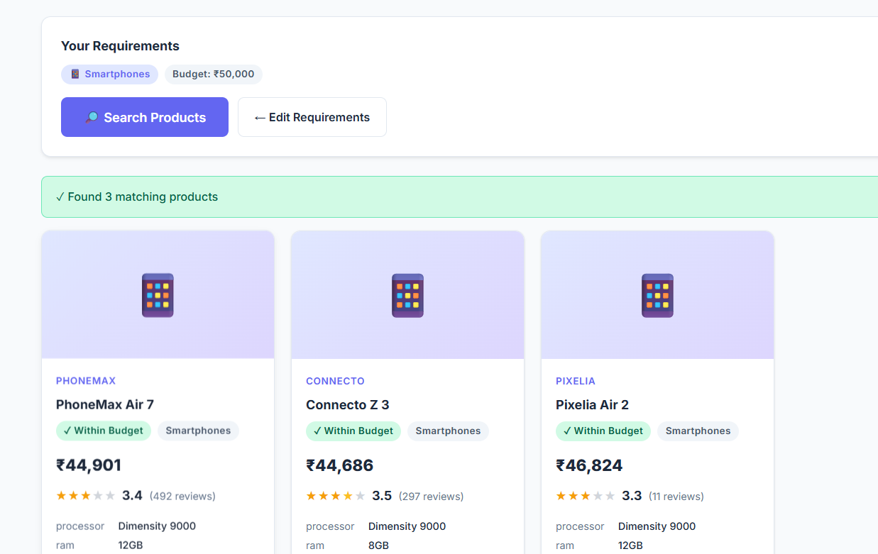

The Products page displays products that match the user’s requirements and budget. It shows key details such as product name, price, category, ratings, reviews, and specifications, helping users quickly compare suitable options.

Recommendations Page
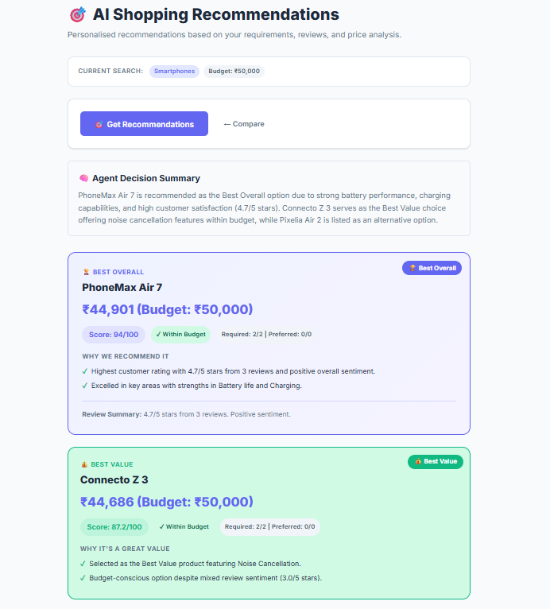
The Recommendations page provides personalized product suggestions based on the user’s requirements, budget, reviews, and product analysis. It highlights options such as Best Overall and Best Value, along with scores and reasons explaining why each product is recommended.
AI Workflow Page
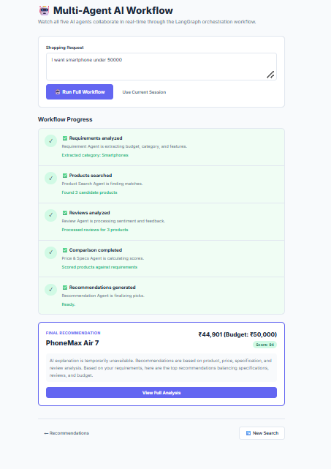
The AI Workflow page shows how multiple AI agents work together to complete the shopping process. It tracks each stage from requirement analysis and product search to review analysis, comparison, and recommendations and presents the final recommended product with its price and score.
Conclusion:
The Multi-Agent E-Commerce Shopping Assistant is a generative AI platform built with LangGraph, RAG and Streamlit that simplifies product discovery and comparison. It uses specialized agents, powered by Gemini 3.3-70B Versatile model, to extract requirements, search the catalog, analyze reviews, compare prices and specifications, and rank products with clear explanations. Because responses are grounded in the product catalog through RAG, recommendations stay accurate and transparent instead of relying only on the model's general knowledge. The project, which covered model selection, agent development, dashboard design and deployment via Ngrok, shows how a collaborative multi-agent structure can turn a time-consuming manual comparison into a fast, personalized shopping experience.
Looking ahead, the assistant offers significant opportunities for expansion, such as integrating live product data through e-commerce APIs, adding user accounts to save preferences and shopping history, supporting multiple languages, adding image-based product search, and deploying to a cloud platform for a permanent public URL. By continuously refining agent prompts and the ranking logic, the platform can evolve from a focused recommendation tool into a comprehensive AI shopping companion.

